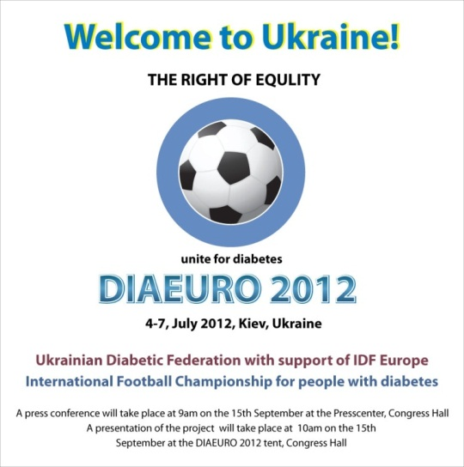

**DiaEuro**

**European Futsal Championship for people with diabetes**

**Medical certificate**

First name of the player _____________________________________________________________

Last name of the player ______________________________________________________________

Country ___________________________________________________________________________

Date of birth: Day ______________ Month __________________ Year _______________________

Type of Diabetes ____________________________________________________________________

Another diagnosis __________________________________________________________________________________

__________________________________________________________________________________

Complications (if present)

__________________________________________________________________________________

__________________________________________________________________________________

Type of treatment (insulin or tablets): __________________________________________________________________________________

__________________________________________________________________________________

**I the undersigned ______________________________________Doctor of Medicine, declare that this player has diabetes and is physical fit to play futsal and participate in DiaEuro 2018 that will be held in Bratislava, Slovakia, in between 21th to 29th of July 2018.**

**Name of the Medical institution that issues Medical certificate:**

__________________________________________________________________________________

**Date _**______________________

**Signature and stamp of the Doctor of Medicine:**